What Is Machine Learning?

Machine Learning is a branch of computer science, that uses statistical techniques to give computer system the ability to “Learn” from data without explicitly programmed.

Machine Learning = Teaching the computer system from the data without explicitly programmed.

Instead of give rules manually ,we give :
1. Data
2. Computer Learns from the Patterns
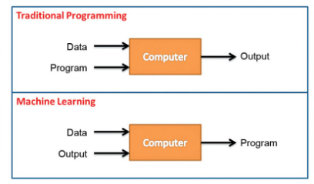

Fig. Traditional Learning Vs Machine Learning

Traditional Learning :
You see in the above fig , when we use tradition learning (Programming) then we give computer data , and write a program on any business problem , and computer generates output based on the give programed

Machine Learning :
But You see in Machine Learning , we gives the computer data , and output related to that , computer learn from the data and create program automatically , don’t need to define each and every conditions manually

Machine Learning algorithm handles each and every conditions Automatically ,doesn’t need to write each and every line of code manually

Example :
Email Spam Detection :
When Gmail says:
👉 “This is spam”

How?
It learns from:
  - Emails marked as spam
  - Words like “Free”, “Win”, “Offer”

In This condition we does not give the specific each and every condition , model learn automatically from the given data and make prediction on it.

